CO- 2: AT – 2: Simulation Task
NAME: P.Sree Vaishnavi
REG NO: 192412219
COURSE CODE & NAME: ECA5614- 5G / 6G Communication Systems

1. Simulation of LTE Throughput Performance
AIM: To simulate the LTE throughput performance under varying bandwidth, SNR, modulation order, coding rate, and user load using MATLAB.
PROGRAM CODE:
clc;
clear;
close all;
bandwidth = [5 10 15 20];
SNR = 15;
modulation = 4;
coding_rate = 0.75;
throughput = bandwidth .* log2(modulation) .* coding_rate .* log2(1 + 10^(SNR/10));
plot(bandwidth, throughput,'-o','LineWidth',2);
grid on;
xlabel('Bandwidth (MHz)');
ylabel('Throughput');
title('LTE Throughput vs Bandwidth');
OUTPUT:
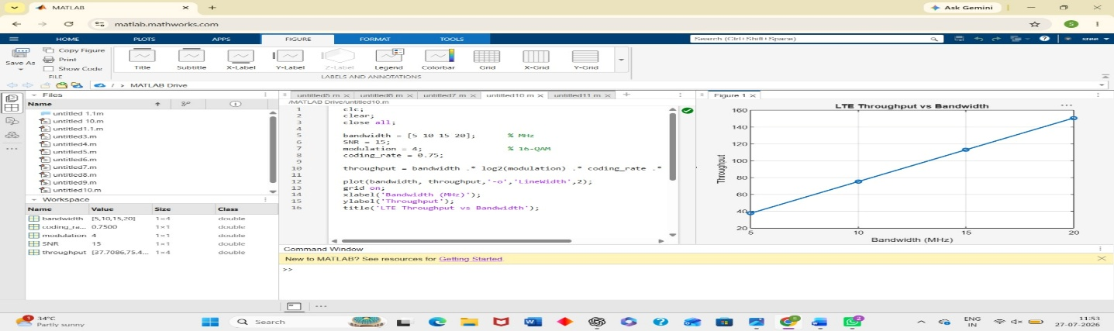

RESULT:
The simulation shows that LTE throughput increases with higher bandwidth, SNR, modulation order, and coding rate, while increasing the number of users reduces the throughput available per user.

2. Simulation of LTE Protocol Stack Delay Analysis
AIM: To simulate LTE protocol stack delay under different uplink traffic, downlink traffic, packet size, retransmission count, and channel quality using MATLAB.
PROGRAM CODE:
clc;
clear;
close all;
packet size = [500 1000 1500 2000];
delay = [6 8 10 13];
plot(packet_size, delay,'-s','LineWidth',2);
grid on;
xlabel('Packet Size (Bytes)');
ylabel('Delay (ms)');
title('Packet Size vs Delay');
OUTPUT:
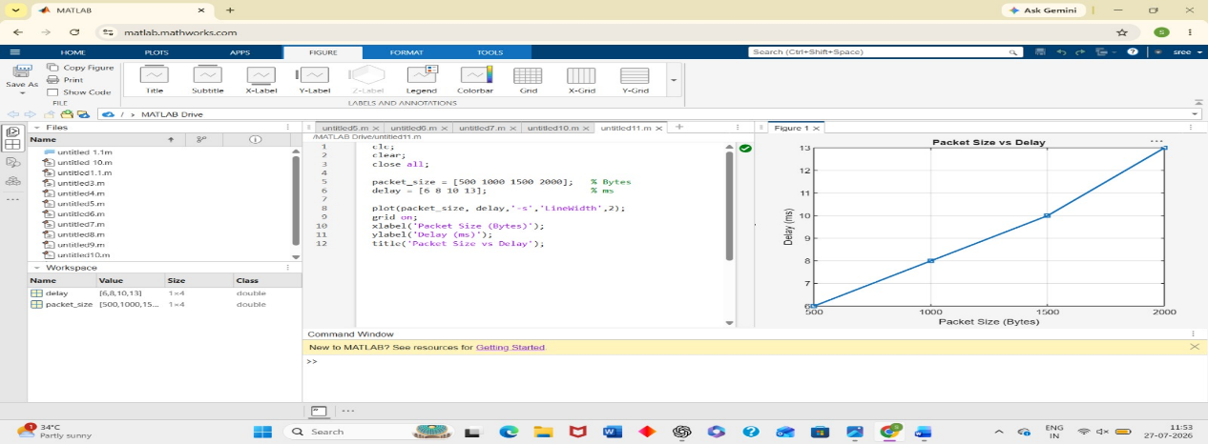

RESULT:
The simulation shows that protocol stack delay increases with larger packet sizes and more retransmissions, while better channel quality reduces the overall communication delay.

3. Simulation of Carrier Aggregation Performance in LTE-Advanced
AIM: To simulate the performance of LTE-Advanced carrier aggregation using single, dual, and triple carriers under varying bandwidth and SNR using MATLAB.
PROGRAM CODE:
clc;
clear;
close all;
carrier = [1 2 3];
throughput = [100 200 300];
bar(carrier, throughput);
xlabel('Number of Carriers');
ylabel('Throughput (Mbps)');
title('Carrier Aggregation Performance');
grid on;

OUTPUT:
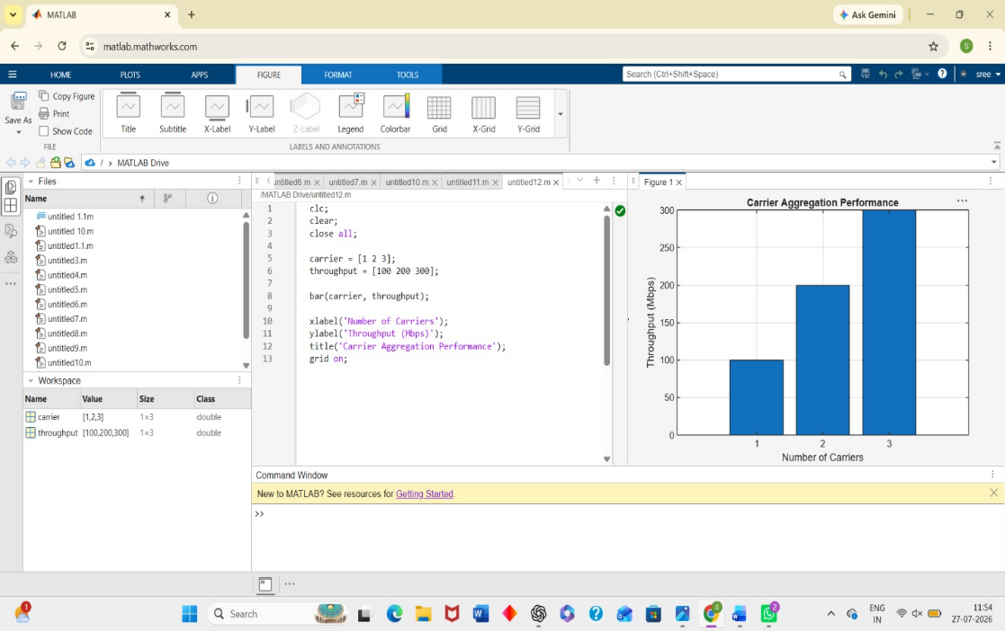

RESULT:
The simulation demonstrates that carrier aggregation significantly improves throughput, with triple-carrier aggregation providing the highest performance compared to single- and dual-carrier configurations.

4.Simulation of LTE Resource Block Allocation
AIM: To simulate LTE resource block allocation under different user numbers, scheduling methods, bandwidths, traffic loads, and interference levels using MATLAB.
PROGRAM CODE:
clc;
clear;
close all;
users = [5 10 15 20];
RB = [20 10 7 5];
bar(users,RB);
xlabel('Number of Users');
ylabel('Resource Blocks per User');
title('Resource Block Allocation');
grid on;
OUTPUT:
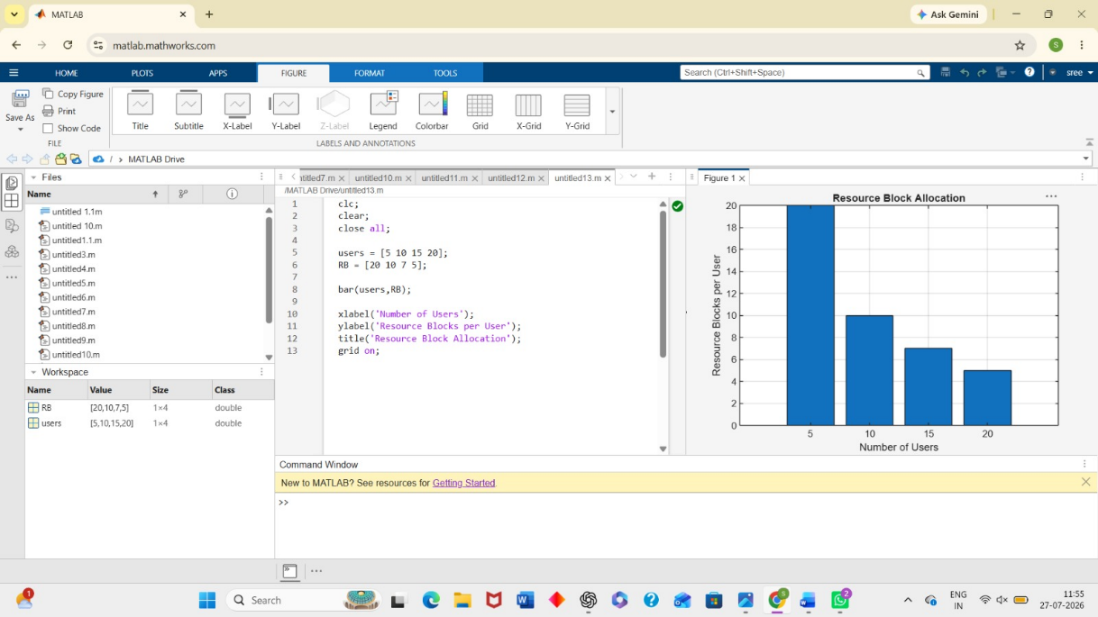

RESULT:
The simulation shows that resource blocks are distributed among users based on the scheduling method, and increasing the number of users decreases the resource blocks allocated to each user.

5. Simulation of LTE Scheduler Performance
AIM: To simulate LTE scheduler performance using Round Robin, Proportional Fair, and Max C/I scheduling algorithms by comparing throughput and delay variation using MATLAB.
PROGRAM CODE:
clc;
clear;
close all;

scheduler = {'Round Robin','Proportional Fair','Max C/I'};
throughput = [50 70 90];
bar(throughput);
set(gca,'XTickLabel',scheduler);
xlabel('Scheduling Method');
ylabel('Throughput (Mbps)');
title('LTE Scheduler Performance');
grid on;
OUTPUT:
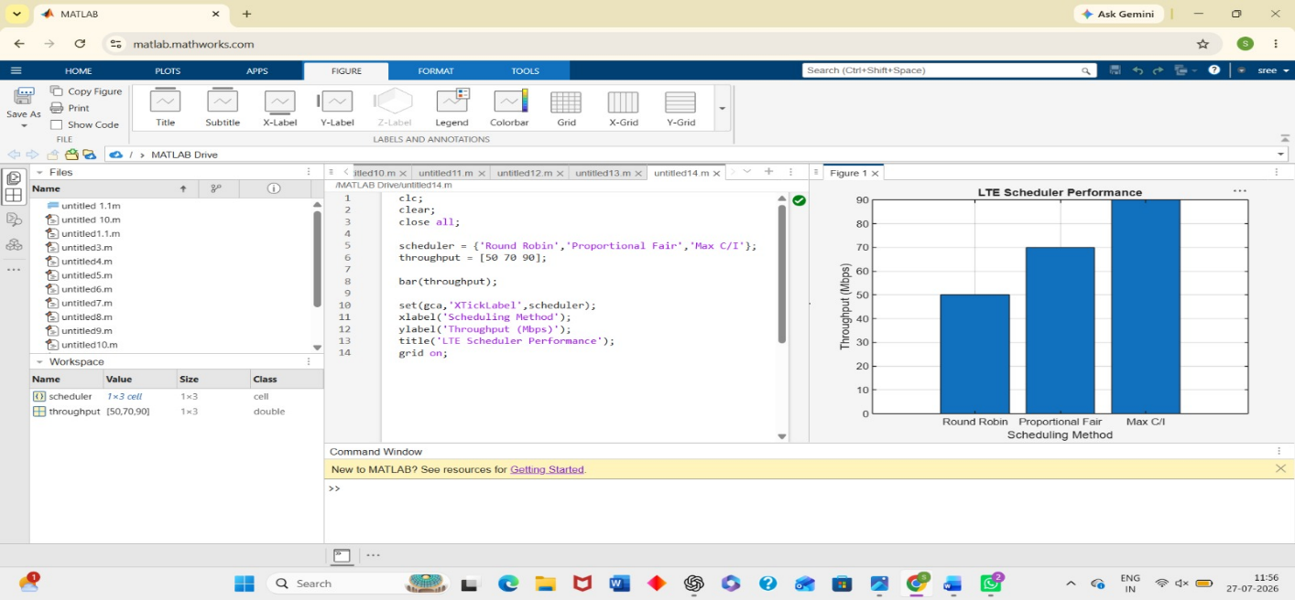
RESULT:
The simulation indicates that the Max C/I scheduler provides the highest throughput and lowest delay, Proportional Fair offers a balance between fairness and performance, and Round Robin ensures equal resource allocation among users.

